**Evidence for Project Unit.**

Marta Beveridge

Cohort E20

**P. 1 Github Contributors page**

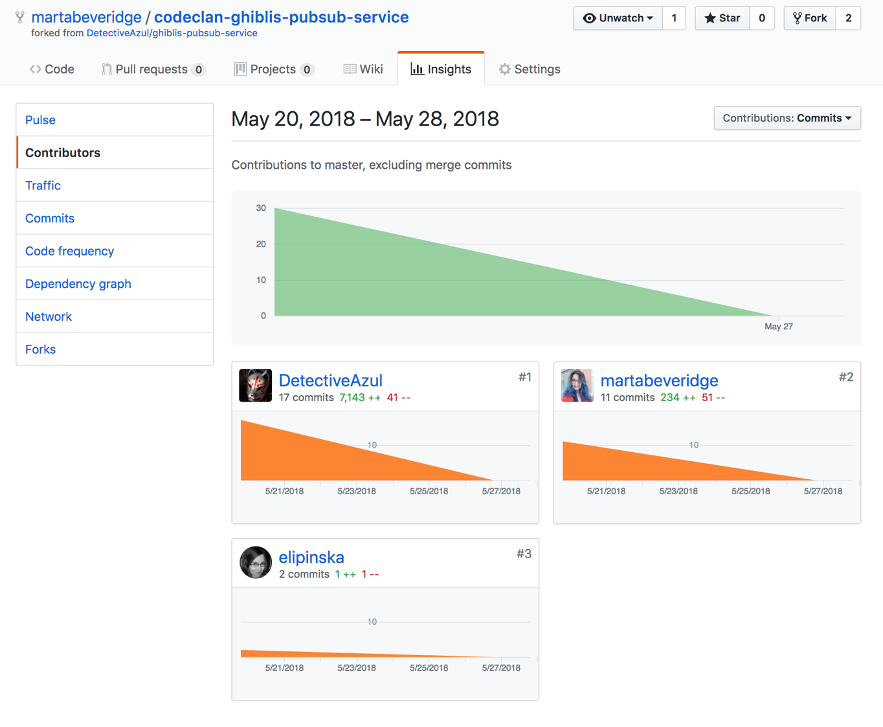

**P. 5 User sitemap**

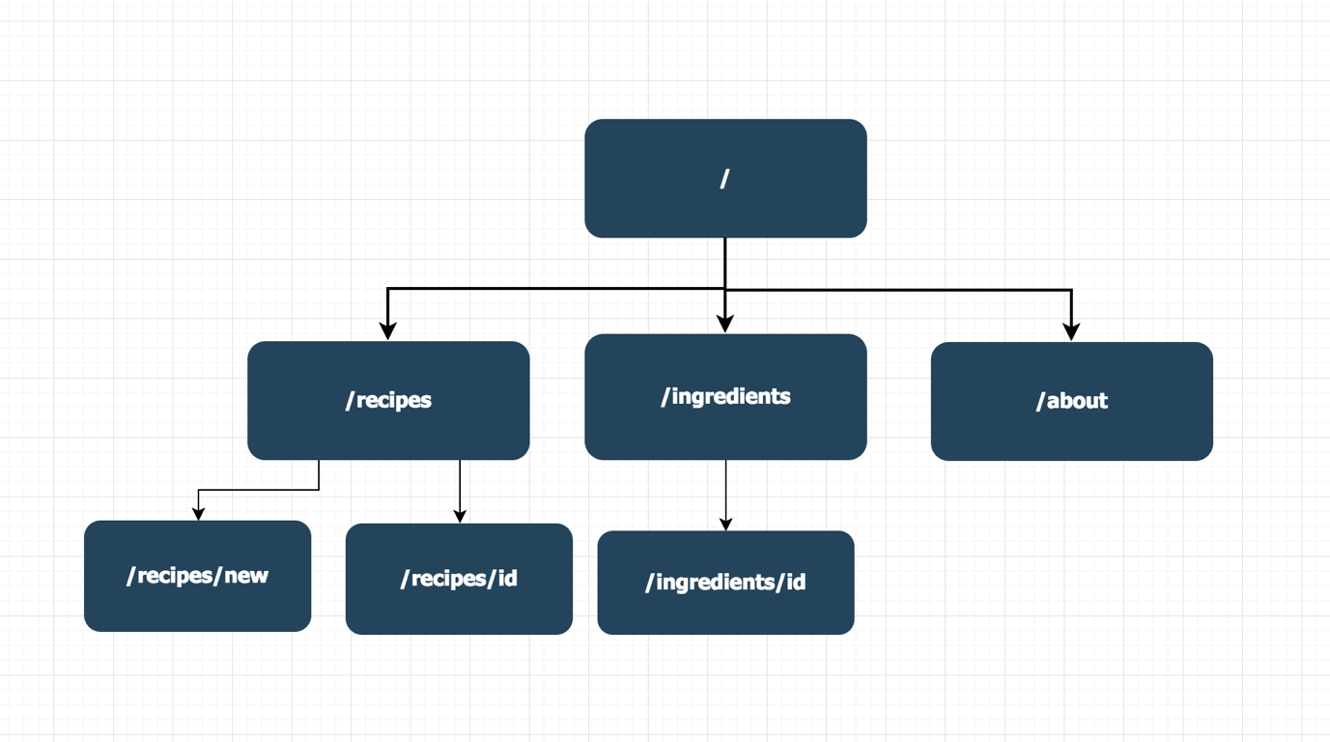

**P. 6 Wireframes designs**

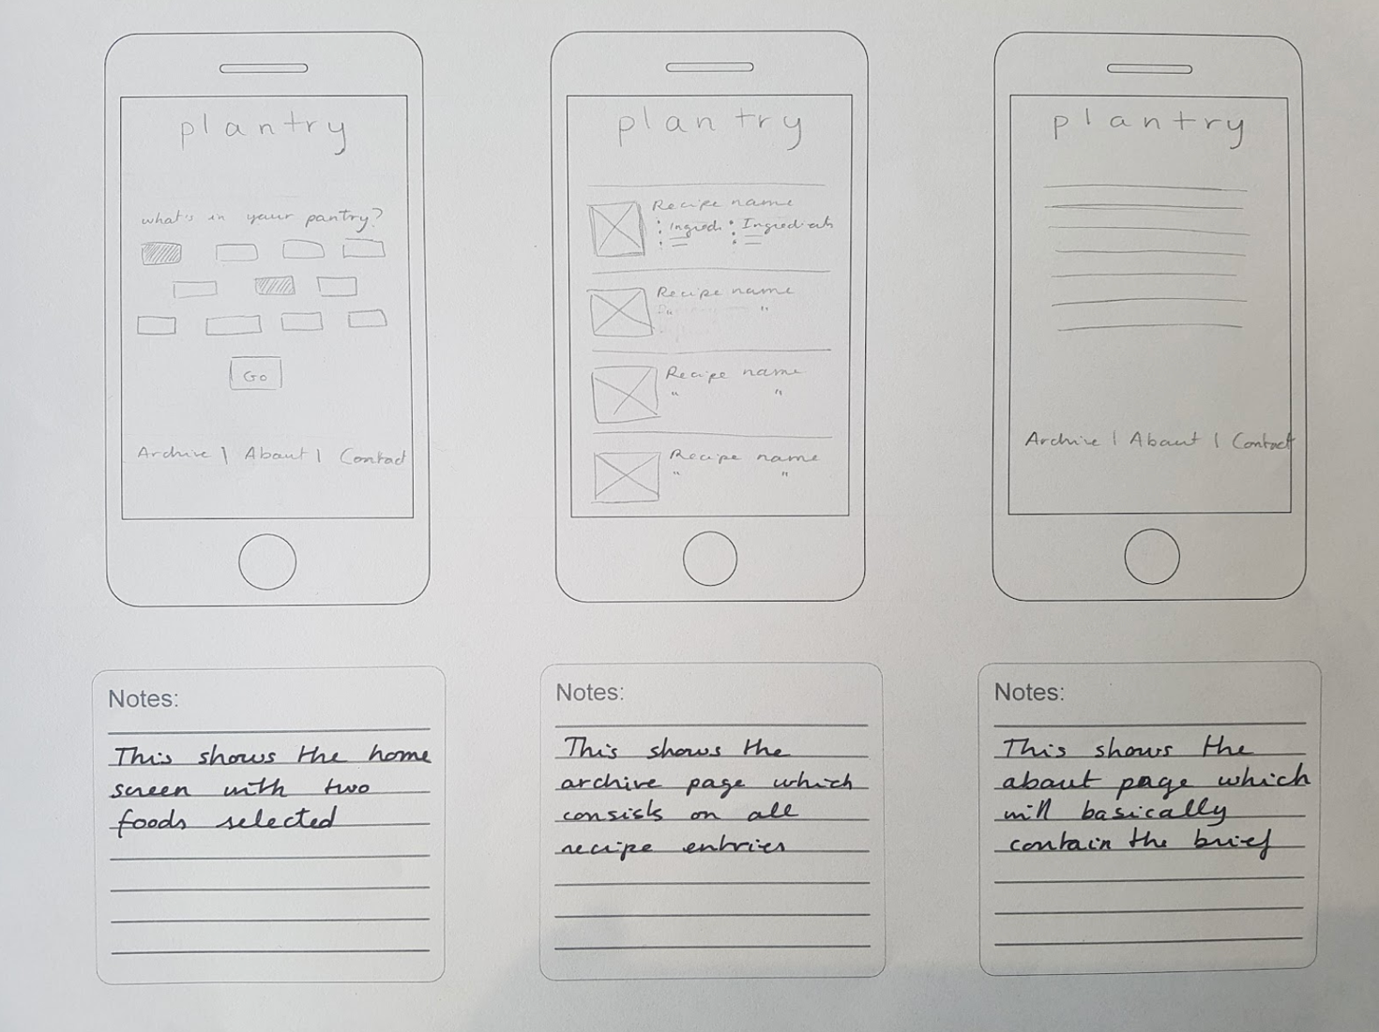

**P. 10 Example of Pseudocode**

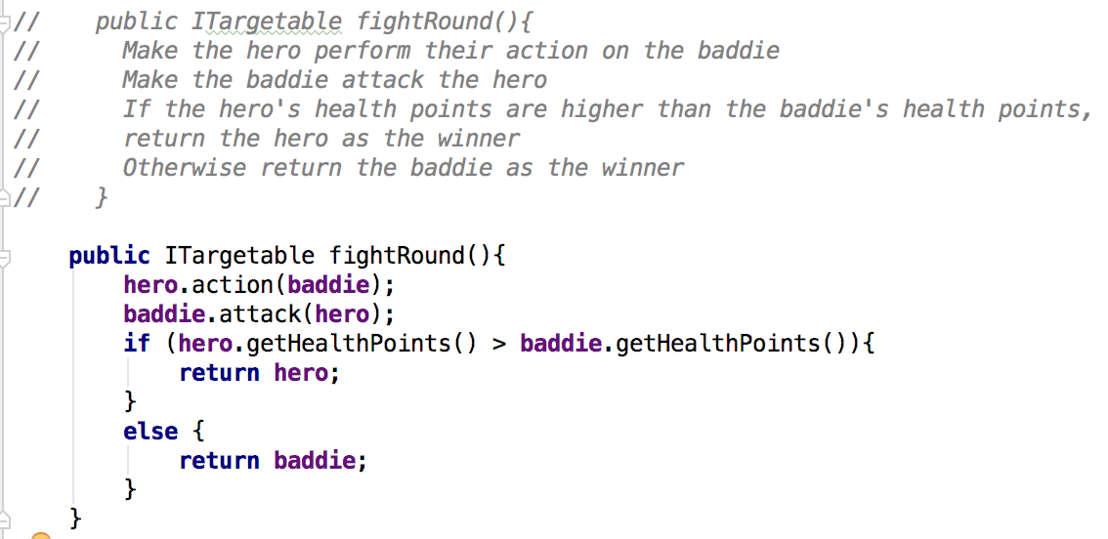

**P. 11 Github link to one of your projects**

<https://github.com/martabeveridge/codeclan-stabagotchi>

**P. 12 Screenshot of your planning and the different stages of development to show changes.**

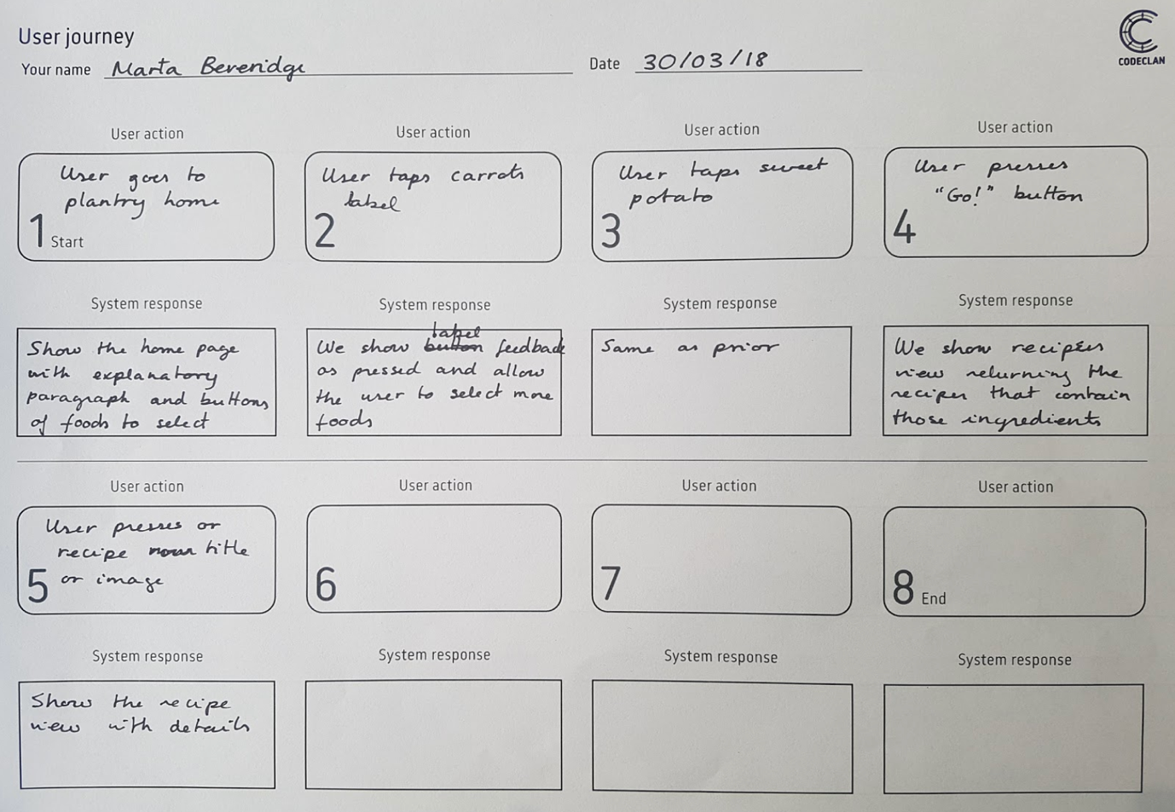

This did not end up being practicable as I only made the recipes searchable by one ingredient.

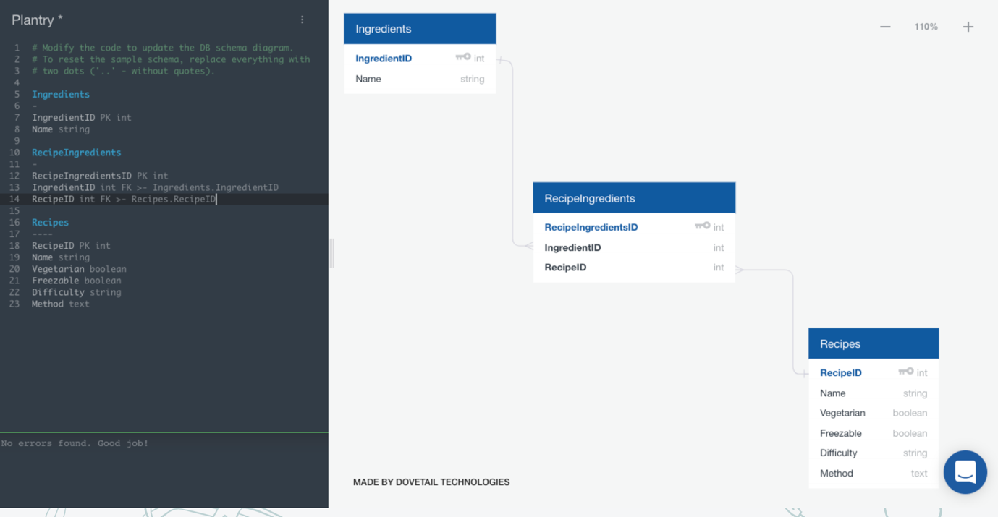

While this was my initial database design, it ended up looking like this:

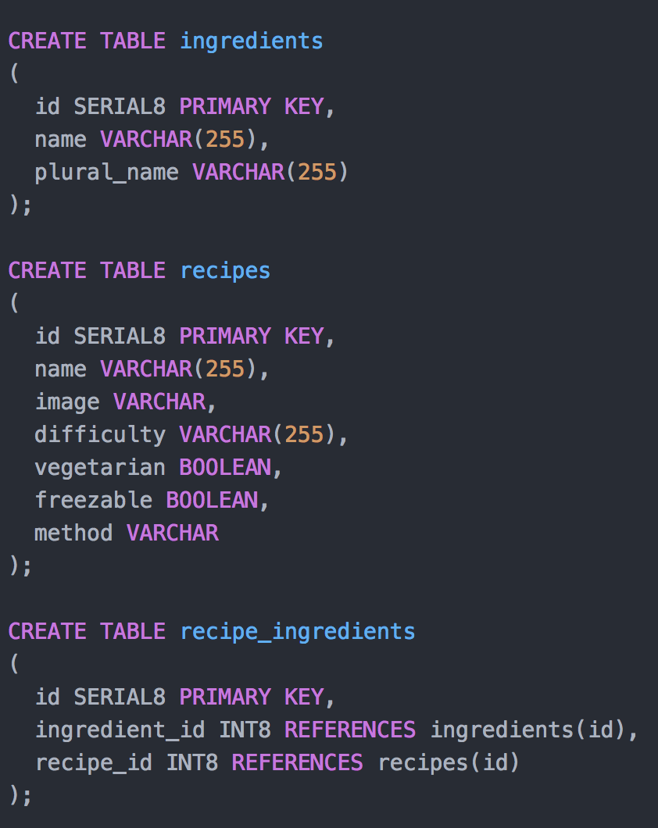

This trello board was used to organise my tasks:

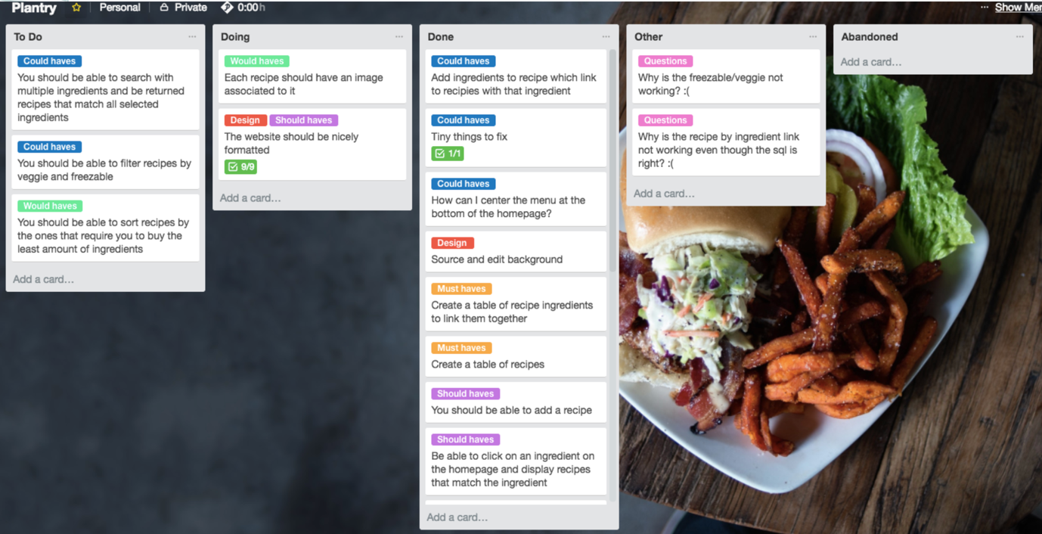

**P. 13 User input**

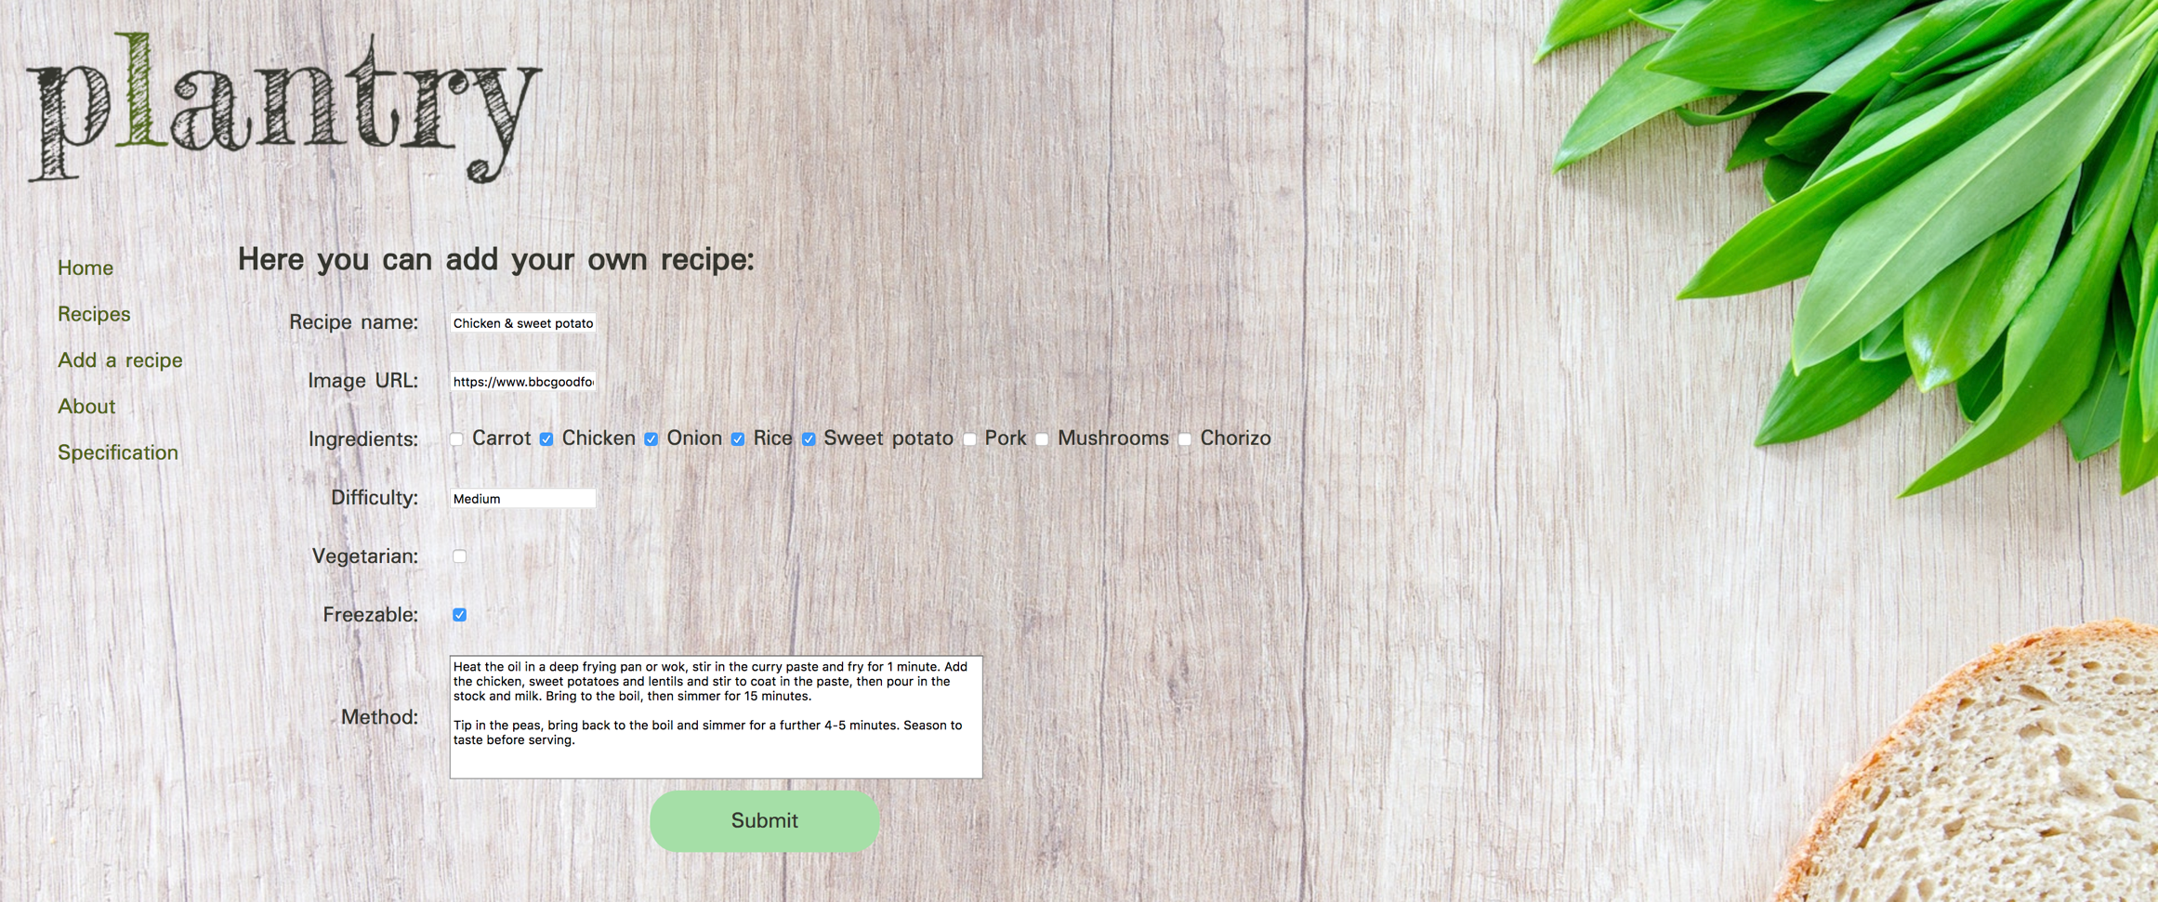

User can fill in the form for a new recipe

**P. 14 Interaction with data persistence**

**P. 15 User output result**

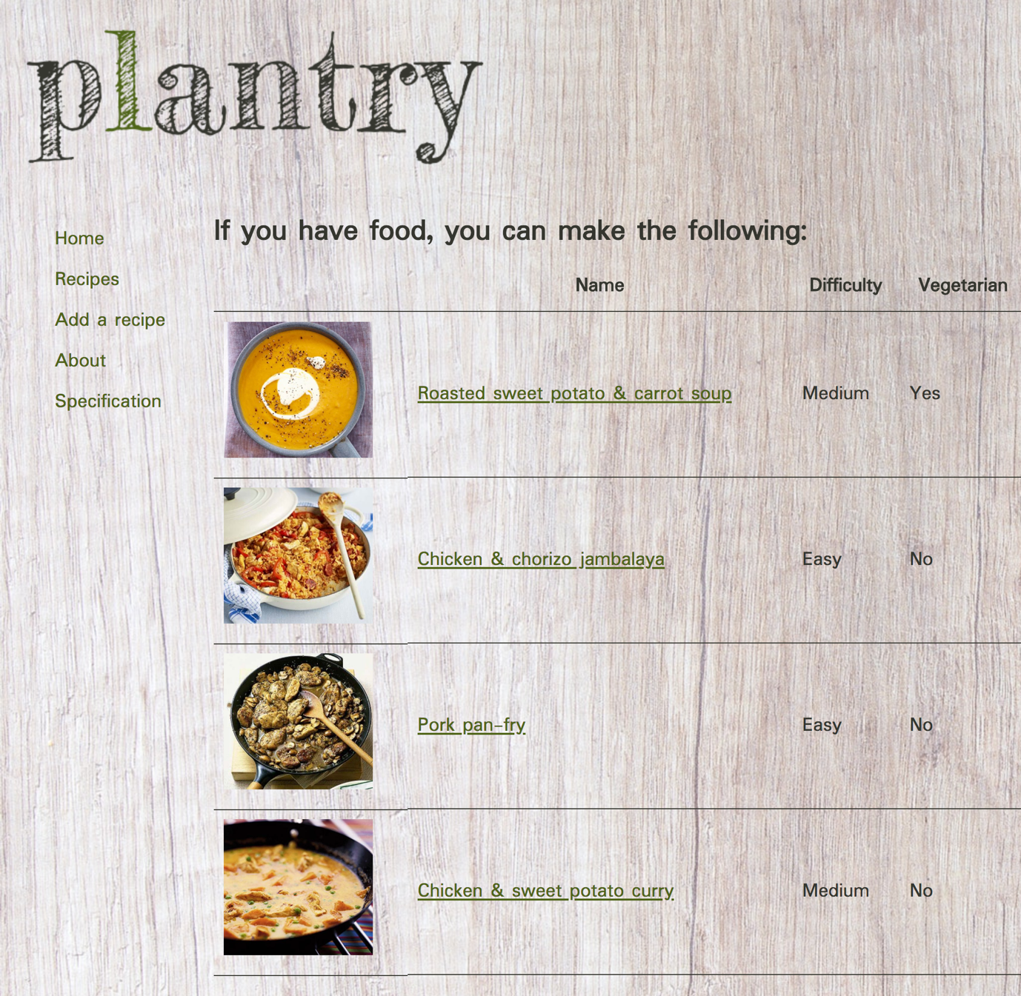

Recipe now appears in the list of recipes so the user can see their output. It can be seen that the recipes have been stored and are still displayed when the window is refreshed. All this can be seen at plantry.martabeveridge.uk.

**P. 16 Show an API being used within your program.**

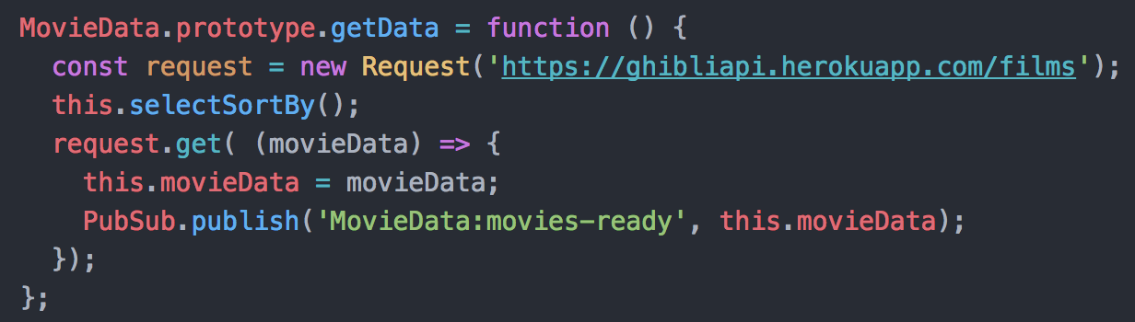

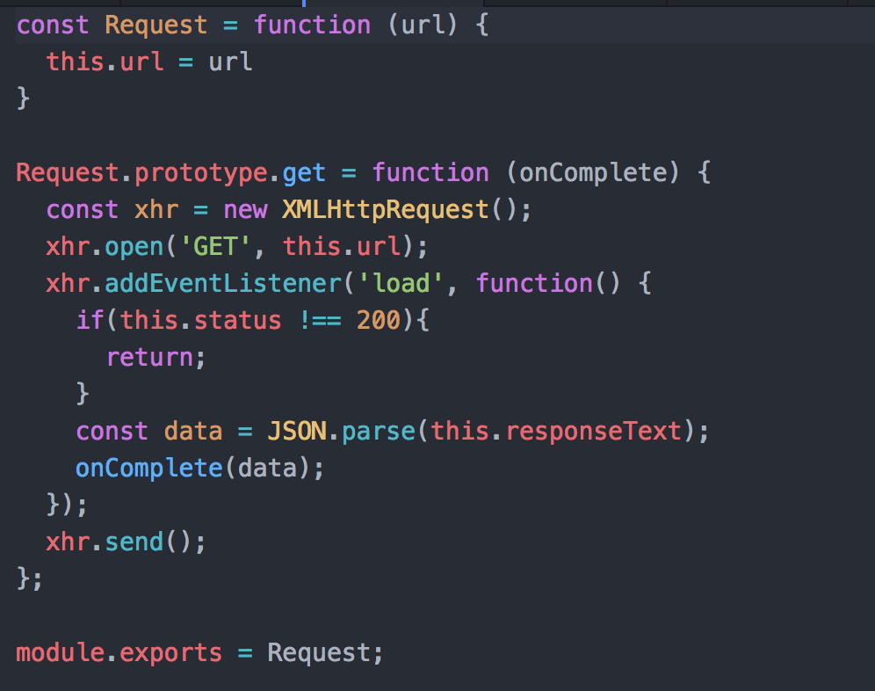

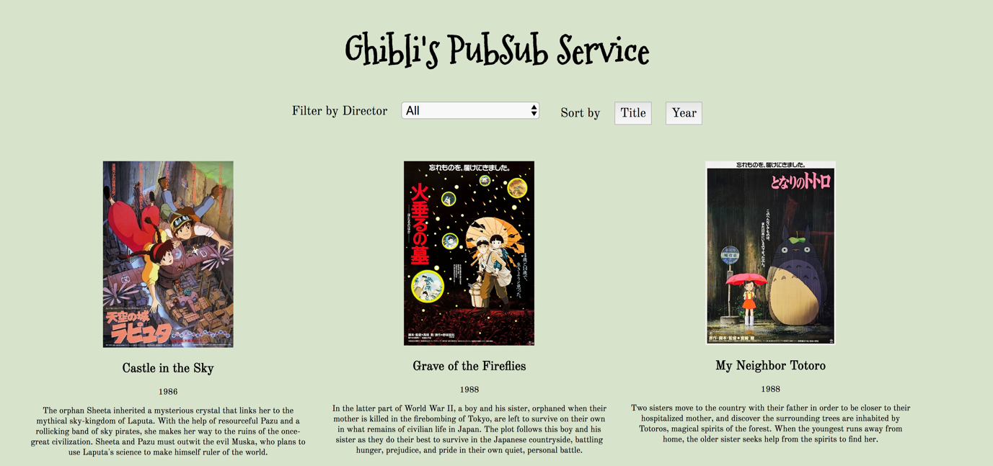

**P. 18 Demonstrate testing in your program. Take screenshots of: Example of test code**

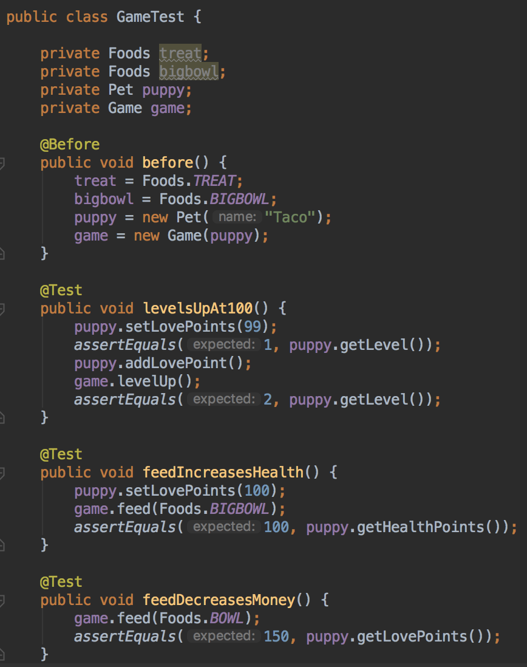

**Test code failing to pass**

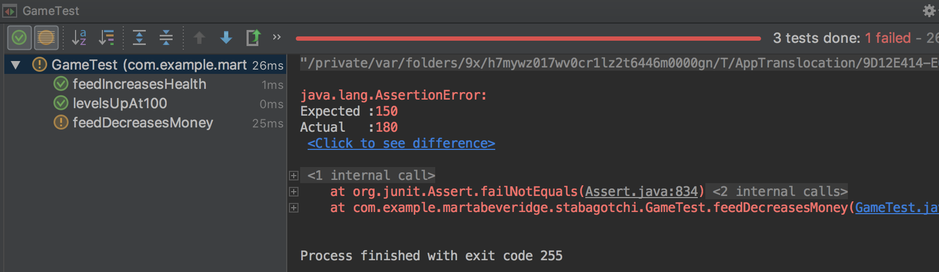

**Example of the test code once errors have been corrected**

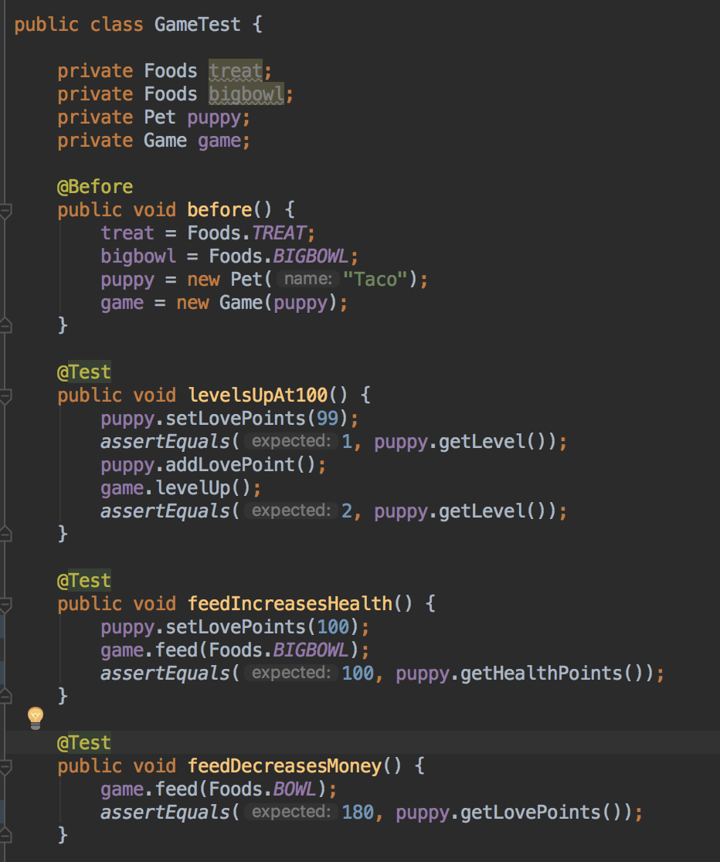

**The test code passing**

